Chapter Four

Implementation, Results
and Discussion

4.1 Introduction
As explained in the previous chapter, the proposed technique consists of two main parts, The Data-collector and the Rule-finder. Each part runs separately during suitable times, to overcome the time consuming, database scans and itemsets frequency generations. In this chapter, the proposed algorithms, which have been developed in chapter three is coded, implemented and tested on real data.
Java has been used to implement the proposed system as a programming language and MySql as a Relational Database Management System “RDBMS”. The advantages of the java programming language and MySql RDBMS over their peers are:
- Java has geed properties for network programming which is suitable for the proposed system to connect multiple database clients to the Proposed System server.
- Usually java is slower than other programming languages like C# for example in Graphical User Interface GUI but it is faster in operation calculations (this is really matter in data mining).
- Java is an OOP, which allows splitting the algorithm into many classes during coding.
- MySql is fast, powerful and simple RDBMS, it works with variety of database engines for example innoDB, MEMORY, MyISAM and ISAM which provide flexibility and availability.
- MySql is widely for web development. The number of Enterprises that use MySql to handle their data are increasing day by day.
- A combination of Java/MySql is convenient, because both are open source and compatible.
4.2 The Databases
The proposed System requires two types of databases to run. The Frequency-base database which contains k tables of k-itemset generated by Data-collector and the client database(s) which contains transaction information.
MySql uses standard Structured Query Language SQL (without special instruction) for handling Queries.
4.2.1 Implementing Frequency-base
Frequency-base is a database stores frequency of every itemset and their subsets (another smaller itemset). It stores different length itemsets in different tables which leads to k tables for k lengths itemsets. The Frequency-base created automatically by Data-collector. Each table has the schema: (Subles(Varchar), Frequency(Numeric)). The SQL code for creating the frequency-base is given in Program 4.1.
The Frequency-base is created by the Data-collector and used by the Rule-finder. This is required for introducing a matching block between the Data-collector and the Rule-finder. This is handled by introducing a Reference Table.
--Create schema of the Frequency-base
CREAT DATABASE IF NOT EXISTS frequencybase;
USE frequencybase;

--Definition of the Frequency-base tables ‘itemset_k’
--where k is the length of itemset stored in this table (it should replaced with numbers).
DROP TABLE IF EXISTS ‘itemset_k’;
CREATE TABLE ‘itemset_k’ (‘subset’ varchar (80) NOT NULL,‘frequency’ int(10) unsigned NOT NULL,
PRIMARY KEY (‘subset’)
)ENGINE =InnoDB DEFAULT CHARSET=latin1;

Program 4.1 SQL statements for creating Frequency-base and its tables

Figure (3.2) Horizontal layouts

4.2.2 Implementing Client Databases
The client databases should contain a table that stores transactions. These databases can be hosted in a single host, separate host or on the same host with the Frequency-base. The schema of transactional table is (ID(Numeric),Item(Varchar)).The SQL codes for creating the client databases is shown in Program 4.2.
--Create schema of the client database
CREAT DATABASE IF NOT EXISTS supermarket;
USE supermarket;

--Create transactional table in the database.
DROP TABLE IF EXISTS ‘transactions’;
CREATE TABLE ‘transactions’ (
‘TID’ int(10) unsigned NOT NULL,
‘Items’ varchar (50) NOT NULL,
PRIMARY KEY (‘TID’, ‘Items’)
)ENGINE =InnoDB DEFAULT CHARSET=latin1;

Program 4.2 SQL structure for creating client database and transactional table

Figure (3.2) Horizontal layouts

4.3 The Proposed Technique Implementation
The implementation strategy for the proposed system is to split each part of the system (The Data-collector and the Rule-finder) into a number of layers. Because java is a full Object Oriented Programming OOP language, each layer may be implemented as an object of class.
In addition to these layers, a number of utility classes are required to ensure the matching and compatibility between layers.
4.3.1 Utility Classes
To Run the System correctly and to make the data communicate between its parts compatible there are needs for some special objects for saving client database information, coding and decoding items, data communicating between layers in a thread safe environment. These classes are:
I. DBServers Class
This class is designed to save information about client databases. The information are: Object host URL, database name, user name, password and last scanned stop for Data-collector. This information is used by the Data-collector to connect with the clients and scanning their transactional databases. The methods (or actions) of this class are inserting new hosts and databases, updating existing hosts and databases, keeping track of last stop of the Data-collector for each client transactional database, saving these information to hard disk, clearing all information and resetting scan stop points for full implementation.
II. CircularBuffer Class
This class is designed to communicate data between layers in a thread safe environment. The protection for thread reaching is kept in an element level not buffer level which provide more efficiency for communication and minimizes waiting time of threads for reaching.
III. ReferenceTable Class
This class provides coding and decoding for information stored inside the Frequency-base. It is actually connects Data-collector, Frequency-base and Rule-finder together, see figure 4.1.
Also, numeric codes is used to keep Frequency-base as small as possible to make sorting for itemsets faster and also to keep Frequency-base consistent if there is multiple clients with deferent coding of items.
Decoding
Encoding

ReferenceTable

The ReferenceTable class is able to register groups of items for the same code number; this is for creating abstraction levels for itemsets. This Class utilizes TreeMap in saving information which guaranties log(n) time to access the elements for more information.

Frequencybase

NetBot

Analyzer

Figure 4.1 Location of ReferenceTable in the proposed system

Figure (3.2) Horizontal layouts
IV. ItemSet Class
The function of this class is to store an itemset and its frequency; it implements a Comparable to be stored in the TreeMap.
4.3.2 The Data-collector Implementation
The function of the Data-collector, as it is developed in chapter three is to fetch transactional data from client databases, and then generate all subsets of fetched itemsets, then counting frequency of every subset and finally saving them in the Frequency-base Data-collector consists of three layers each layer can be represented as a class in the java environment.
I. Scanner Class
The function of this class is to scan the client databases, fetch transactional data in a block level, create the itemsets, and finally encodes the fetched data according to the ReferenceTable. The scanning process starts at the last stopped for fetching data using the following SQL routine:
SELECT tid, items
FROM tableName
Limit LAST_STOP, FETCH_SIZE;
Where: tableName is the name of current databases table, LAST_STOP is the latest stop point for last scan of this database by Scanner and FETCH_SIZE is the block size.
Scanner pushes the itemsets in the circular buffer then proceeds to create next itemset.

II. ItemsetGenerator Class
This class uses the temporary itemsets in the circular buffer; create non-empty subsets, then save the subsets with their frequency of appearance in buffers according to the length of each subset.
The time requirements for executing this class’s routines is rising exponentially when the length of the itemset increases, see figure 4.2. When each buffer reaches its maximum size, it pops its data to another circular buffer between the ItemsetGenerator and the Data-collector class see figure 4.3.
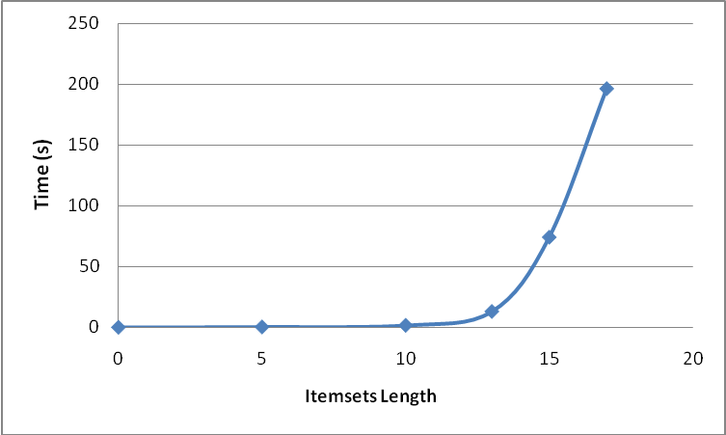

Figure 4.2 Time-Itemset relationship length
for generating all subsets of transactions for 512 records

Figure (3.2) Horizontal layouts

Figure 4.3 data flow between Data-collector layers

Figure (3.2) Horizontal layouts
1-itemset buffer
k-itemset buffer
2-itemset buffer
1-subset, frequency
2-subset, frequency
k-subset, frequency
Itemset
(subset, frequency)
buffers

Scanner

ItemsetGenerator
k-buffers

FB Creator

Circular
Buffer

Circular Buffer
From Client DBs
To Frequency-base
III. FBCreator Class
This class is the main class of the Data-collector. It triggers the Data-collector to start, that means, it controls other two lower level layer classes (the Scanner and the ItemsetGenerator) to support this layer in its task to create its data, and then save them in Frequency-base. Data is received to this layer in block level of (k-itemset, frequency) from the circular buffer between the ItemsetGenerator and the Data-collector.
4.3.3 The Rule-finder
Rule-finder is the last part of the proposed System. It is more interactive with the users by interpreting their commands to output reports of association rules. As stated in chapter three, the Rule-finder is divided to two layers: the Rule-finder and the RuleGenerator. Each layer can be implemented as a class in the Java environment.
I. Rule-finder Class
This class takes the order from users. It uses the Frequency-base to produce blocks of up to 256 units and send it to the RuleGenerator. It captures the user’s selection of the association rule. The proposed Technique supports three types of rule generation:
- Selective Itemsets: This type of rule generation takes a group of itemsets and outputs support and confidence of each rule can be generated by this group.
- Selected length of itemsets: In this type, the users gives the Rule-finder minsup and minconf for specific k length of itemsets, which means the Rule-finder will search k^{th} table in the Frequency-base for generating rules.
- Apriori simulation: In this type, it is only required from the user is to provide minsup and minconf to generate rules similar to the Apriori algorithm.
II. RuleGenerator Class
This layer uses the output of the Rule-finder class to generate rules. To speed up the process of finding rules and minimizing queries as low as possible, twisted Apriori’s Simple rule generator is used. This class’s instance outputs its data (rules) to the text file because it’s more convenient for reviewing, reporting and printing.
4.4 The Proposed System Verification
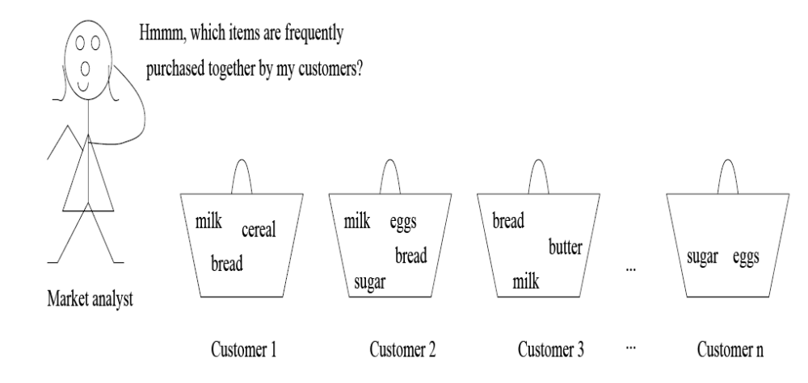
The next step to the implementation of the proposed system is its verification. There are many verification approaches in Software Engineering point of view. In this thesis, a comparison method has been used to see the accuracy of the proposed and implemented System. The comparison method is working if there are some benchmarks or published solved problems. We have searched the internet and the existence resources, but we have failed to find a standard benchmark. Hence we are going to use an example in the book of Jiawi and Micheline “Data Mining: Concepts and Techniques” to check the proposed system. This example is used as a benchmark to make the verification for the two parts of the system individually. The selected example is example 6.1[JIAW01]. It applies a market basket analysis for an ALLElectronic supermarket.
Figure 4.4 Market Basket analyses
To verify the Data-collector, all frequencies of the 3-itemsets have been determined manually, results are listed in figure 4.5.a, while figure 4.5.b shows results of the itemset_3 table of the Frequency-base, and figure 4.5.c shows the result of Jiawi. The results are 100% match. Just Note that the itemset's codes has been changed in itemset_3 table with their real names using ReferenceTable for human interpretation.
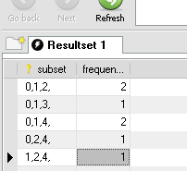
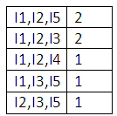
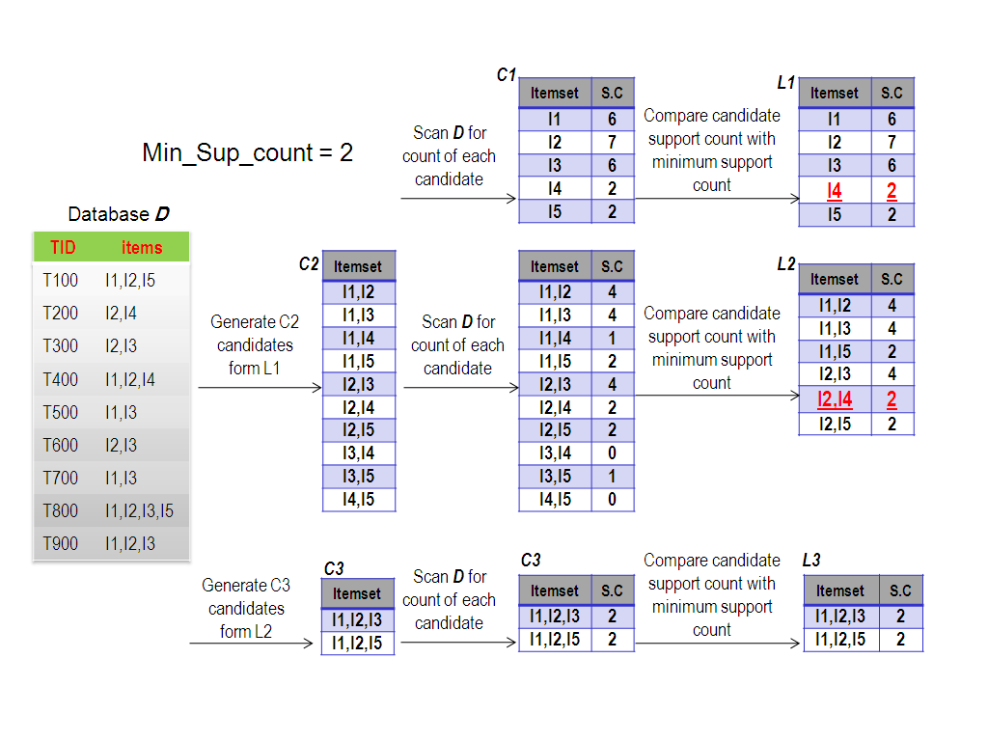
The second verification is going to the Rule-finder. The Apriory simulation method which has been used in the Rule-finder design is applied to the output data of the Data-collector. The results are shown in figure 4.6. It shows that the published results are 100% match with the Rule-finder results.
c- Jiawi’s Results
a- Manual Result
b- NetBot Result

Figure 4.5 Data-collector verification

Figure (3.2) Horizontal layouts

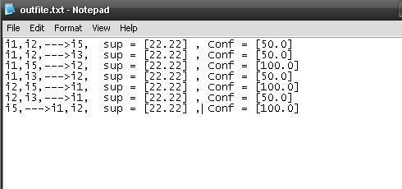

a- Rule-finder’s result

Figure 4.6 Rule-finder verification

Figure (3.2) Horizontal layouts

i₁,i₂⟹i₅ [sup = 22.22% ; Conf = 50%]
i₁,i₂⟹i₃ [sup = 22.22 % ; Conf = 50% ]
i₁,i₅⟹i₂ [sup = 22.22 % ; Conf = 100%]
i₁,i₃⟹i₂ [sup = 22.22 % ; Conf = 50% ]
i₂,i₅⟹i₁ [sup = 22.22 % ; Conf = 100%]
i₂,i₃⟹i₁ [sup = 22.22% ; Conf = 50% ]
i₅⟹i₁,i₂ [sup = 22.22% ; Conf = 100%]

b- Manual results

Figure 4.6 Contended

Figure (3.2) Horizontal layouts

Figure 4.7 An example of Apriori strong itemset detection

Figure (3.8) Example of frequencybase construction

4.5 Application of the Proposed System
After the completion of all implementation requirements and system verification, the proposed System has been tested on real data. In this section, the testing procedure together with the results is described.
4.5.1 Test Setting
The proposed system is ideally designed to work on a network of client databases and a proposed system server. The Data-collector collects transactional data on the network and builds Frequency-base in scheduled time. Then the Rule-finder produces association rules as reports according to the user's order. The proposed system can also work on a single computer with client databases on the same computer. In this case, the amount of time required to transfer data over the network is reduced but more disk space is required, because the client database and Frequency-base are placed on the same storage medium.
The following preparations are set for the testing:
- The Infrastructure
  - The server computer: HP computer with Intel core due CPU at 2.16GHz speed and 1 GB main memory.
  - The client computers: two locally collected computers with Intel Pentium 4 at 3 GHz speed and 512 MB main memory are used.
  - The underlying network: 100 mb/s network adapters with FTP CAT 6 are used to connect computers with a switch by using star topology.
  - The software: all computers’ operating systems are Windows XP SP2, The database servers are MySql Essential (Version 5.0.27), and Java JDK (version 1.5) and JDBC mysql-connector-java (Version 5.0.4) are used.
- The Data: A fraction of Kok supermarket in Erbil of one weak is considered. The data it consists of nearly 15000 records with 600 items. After data cleaning and using an abstraction level it became nearly 11000 records with 200 items.
4.5.2 Data Cleaning and Abstraction
The real data available was not clean. Latin characters were mixed with Arabic characters and numbers. Different item names were used for one item. All the data have been cleaned manually to rise the reality and reliability of the test.
A data with 15000 records and 1000 different items are used in the test. An abstract algorithm is used according to the ReferenceTable to abstract the data and reduce the items into nearly 200 groups of items. These 200 items have been considered as input to the system.
4.5.3 Testing the Data-collector
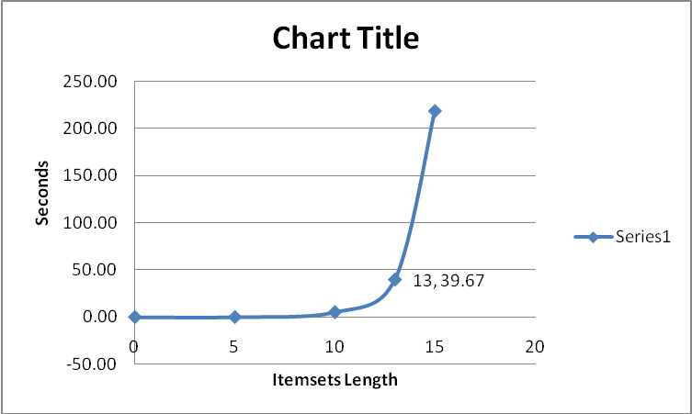
The Data-collector is used to find all itemsets according to user's criteria on the length of the iremsets, in other word, the maximum filter.For the abstracted Kok's data, a portion of the output for different itemset lengths are shown in tables 4.2. This process is time consuming. Its time-itemset length for the test data is shown in figure 4.8. The figure shows that the time is linearly rising with increasing number of records and the itemset length.

Figure 4.8 Time requirement for generating frequencies of subsets

Figure (3.2) Horizontal layouts
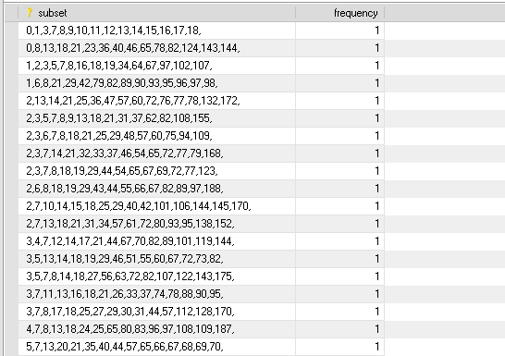
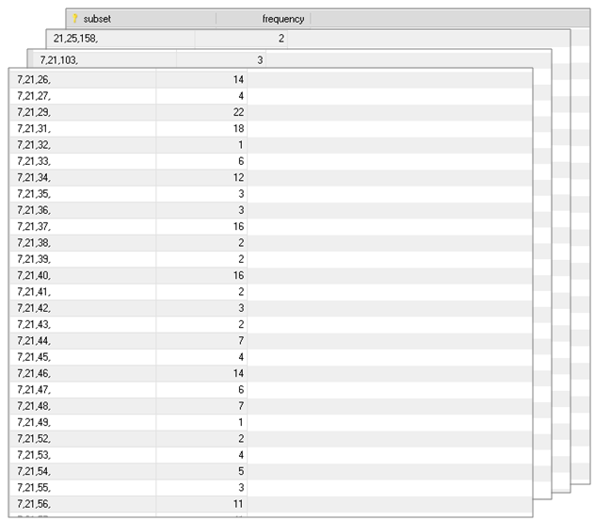
a- itemset_15

Figure 4.9 Samples of Frequency-base tables

Figure (3.2) Horizontal layouts
b- itemset_3
4.5.4 Testing the Rule-finder
The Rule-finder has been applied to the output of the Data-collector. Three different type tests are carried out to generate special rules accordingly. Rules are specified by the user.
- Testing Rule Generation for Selective Itemsets
This type of rule generation is more directed and more efficient than the other two types. Four tests are carried out for this rule generation type. The time specifications and the results are given for each test.
Test 1: items selected {biscuit, honey, jelly}
Time required: 31 ms
biscuit, honey ⟹jelly sup = [0.07] , Conf = [5.55]
biscuit, jelly ⟹honey sup = [0.07] , Conf = [5.26]
jelly, honey ⟹biscuit sup = [0.07] , Conf = [100.0]
honey ⟹biscuit, jelly sup = [0.07] , Conf = [2.17]
biscuit ⟹jelly, honey sup = [0.07] , Conf = [0.15]
jelly ⟹biscuit, honey sup = [0.07] , Conf = [3.7]
Test 2: items selected { syrup, soap }
Time required: 17 ms
syrup ⟹ soap sup = [0.61] , Conf = [1.7]
soap⟹ syrup sup = [0.61] , Conf = [21.05]
Test 3: items selected {tea, biscuit}
Time required: 16 ms
tea ⟹biscuit sup = [2.94] , Conf = [43.67]
biscuit ⟹tea sup = [2.94] , Conf = [6.01]
Test 4: items selected {tea, shampoo, toy}
Time required 0 ms
No itemsets found
II Testing Rule Generation for Selected Length of Itemsets
The second criteria has been used by the user includes the minimum confidence, the support and the length of itemsets. Results for some applied criteria are shown in table 4.1. The table shows the efficiency of rule generation and number of rule generated by the system. It is shown that smaller minsup requires more execution time but it still too small relative to the Data-collector’s time requirement. Figure 4.10 shows the time-minimum support for k-length itemset for minconf constant at 50%.

Table 4.1 time requirement and number of
discovered rules for K length itemset

Figure (3.2) Horizontal layouts

Itemset Length | Minimum support | Time (seconds) | No. of Rules
2 | 0.001 | 0.250 | 1305
2 | 0.005 | 0.156 | 508
2 | 0.010 | 0.094 | 283
2 | 0.050 | 0.031 | 35
3 | 0.001 | 1.219 | 17090
3 | 0.005 | 0.250 | 1700
3 | 0.010 | 0.156 | 569
3 | 0.050 | 0.031 | 6
4 | 0.001 | 2.953 | 48286
4 | 0.005 | 0.250 | 1190
4 | 0.010 | 0.110 | 184
4 | 0.050 | 0.047 | 0

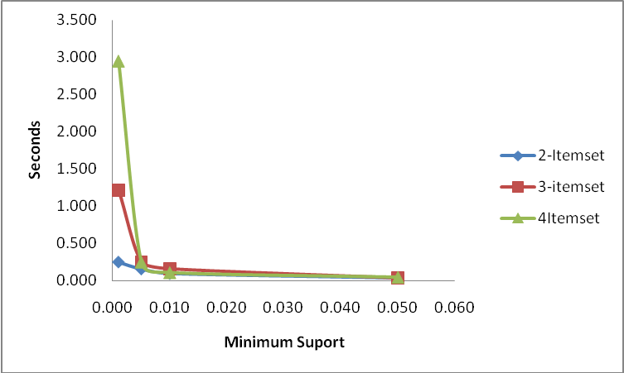

Figure 4.10 Time requirement for generating for K length itemset

Figure (3.2) Horizontal layouts

III Testing Rule Generation for Apriori Simulating
In this test, the minConf constant is kept at 50% and change minSup to find the required association rules. The time requirement is larger than previous way due to searching in the tables for finding itemsets with provided minSup. In this case, the length of itemsets is determined by minSup which called frequent itemset [RAKE94].

Table 4.2 time requirement, number of discovered rules and Itemset Length for Apriory simulated results

Figure (3.2) Horizontal layouts
Minimum Support | Max Length | Time (Seconds) | No. of Rules
0.001 | 11 | 37.33 | 216622
0.005 | 5 | 10.00 | 575
0.01 | 4 | 5.32 | 151
0.02 | 3 | 0.12 | 33
0.03 | 3 | 0.1 | 17
0.04 | 3 | 0.108 | 7
0.05 | 2 | 0.033 | 4

